EC-231 Operating Systems
BS(CE)-2021
LAB REPORT # 2

Submitted By:
Reg. No. | Name
21-CE-009 | Huzaifa Shahbaz

Department of Computer Engineering
BS Computer Engineering Program
HITEC University Taxila
 | Presentation  (Format (0.5) + Title (0.5) +  Conclusion(1) + Procedure(2) + Objective(1)) | Calculation/Coding | Observation/ Program Results | Total
Total | 5 | 5 | 5 | 15
Obtained

___________________________
Lab Instructor.
Engr. Fasih Ahmad
Experiment #2
Linux Shell commands for file operations and their rights
Objective: The main objectives of this lab are to understand: 1. How to view or edit a text file in Linux. 2. How we can concatenate two or more files into a single file, 3. How to sort contents of file 4. How to display specific lines of a file 5. How to assign different permissions to the file using commands in Ubuntu operating system.

Software Used: 1. Ubuntu 2. Virtual box

Procedure: 1.ls: Use the `ls` command to list files and directories in the current directory. It provides information about file names, sizes, and permissions. 2.chmod: The `chmod` command is used to change the permissions of files and directories. It allows you to specify who can read, write, or execute a file. 3. chown: With the `chown` command, you can change the ownership of a file or directory. This command is often used to transfer ownership between users or groups. 4. cp: Use the `cp` command to copy files and directories from one location to another. It creates a duplicate of the file or directory with the specified permissions. 5.mv: The `mv` command is used to move files and directories from one location to another. It also allows you to rename files and directories. 6.rm: Use the `rm` command to remove files and directories from the system. Be cautious when using this command, as it permanently deletes the specified files. 7. mkdir: The `mkdir` command is used to create new directories. You can specify the name and permissions of the directory to be created. 8. rmdir: Use the `rmdir` command to remove empty directories from the system. Similar to the `rm` command, be careful when using `rmdir` as it deletes directories permanently. Understanding file permissions: 1. In Linux, file permissions are represented by three sets of characters: user, group, and others. 2.Each set can have three permissions: read (r), write (w), and execute (x). 3.The `ls -l` command displays file permissions in the format `drwxr-xr-x`, where the first character indicates the file type, followed by three sets of permissions for user, group, and others. Understanding file ownership: 1.Each file and directory in Linux has an owner and a group associated with it. 2.The `chown` command allows you to change both the owner and the group of a file or directory. These commands and concepts form the foundation for managing files and directories in a Linux environment, enabling users to control access and organization effectively.

Task
Task 1: Show Simulation results after performing the following tasks by using suitable commands in Linux. Also show command/commands used for specific task a. Create 3 empty text files and name them as students.txt, pstudent.txt and fstudents.txt. b. Assign permissions to read only permission to the user. c. Enter at least 10 10 different students’ names in pstudent.txt and fstudent.txt. If any error appears, debug that error for user only. d. Now create directory named HITEC and assign permissions of read only to user and group. e. Copy all files to directory HITEC. If any error appears, debug that error for user and group only. f. After that append the file students.txt with first five sorted names from pstudent.txt and last five sorted names from fstudent.txt. g. Show the contents of sorted names from file students.txt. h. Change the permissions of file students.txt read only and both other files read and write only. i. Now append another student name in student.txt file. j. Display contents of all the files. k. Show permissions and all of the file contents of HITEC.
Stimulation: 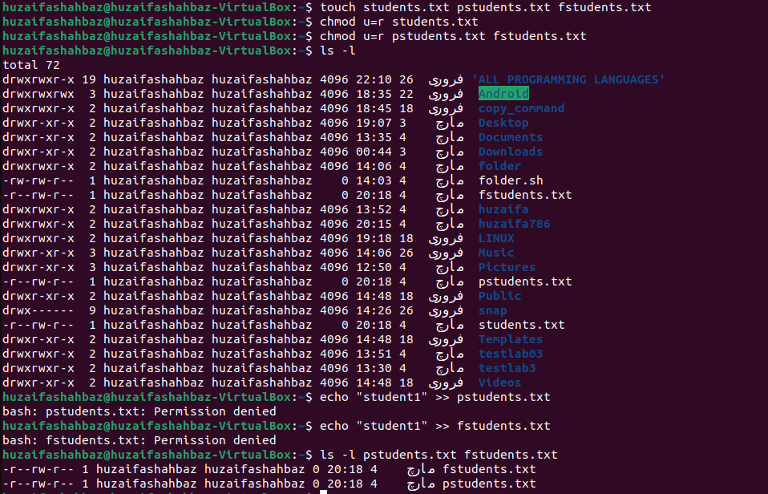 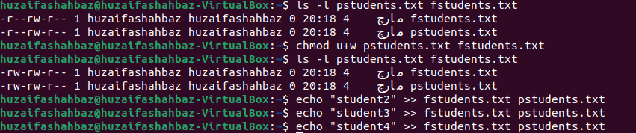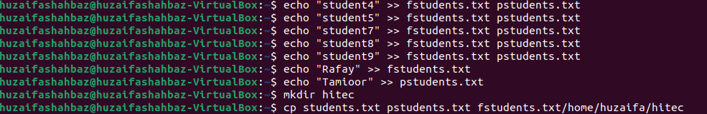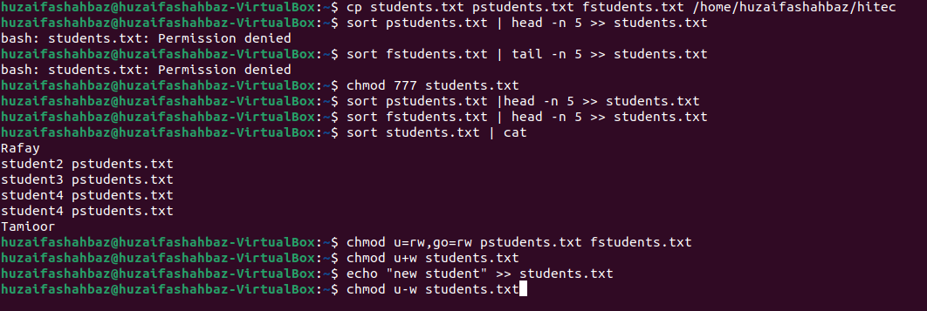 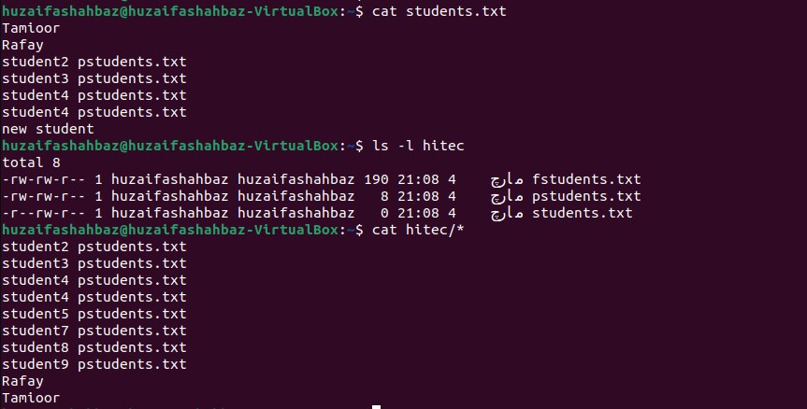
Conclusion: In conclusion, Linux shell commands allow for efficient file operations such as creating, copying, relocating, and deleting files, as well as managing file permissions with chmod and chown. These commands allow users to effectively alter files, directories, and permissions, which improves system security and organization. Understanding and using these commands is required for effective file management and system administration in Linux systems.

